**POC for windows SERVER HARDENING**

-Install the latest service packs and hotfixes from Microsoft.

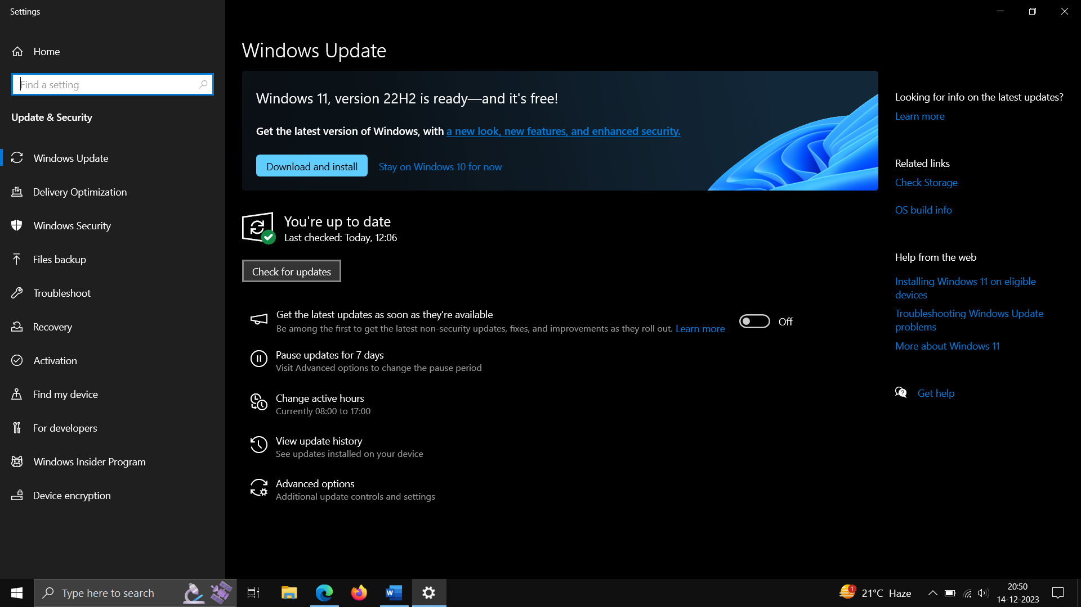

Keep the windows up to date regularly – check for update.

-Enable automatic notification of patch availability.

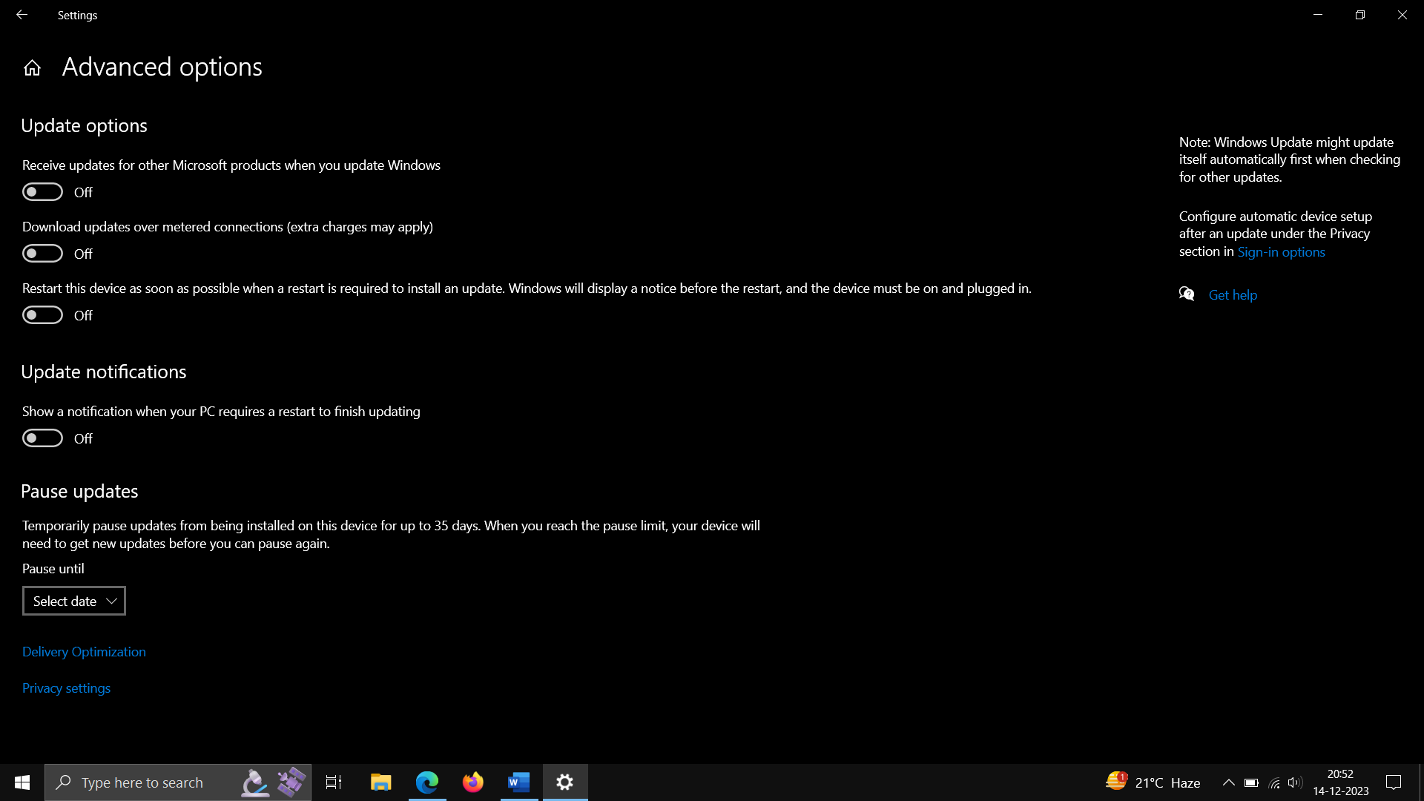

-Set minimum password length.

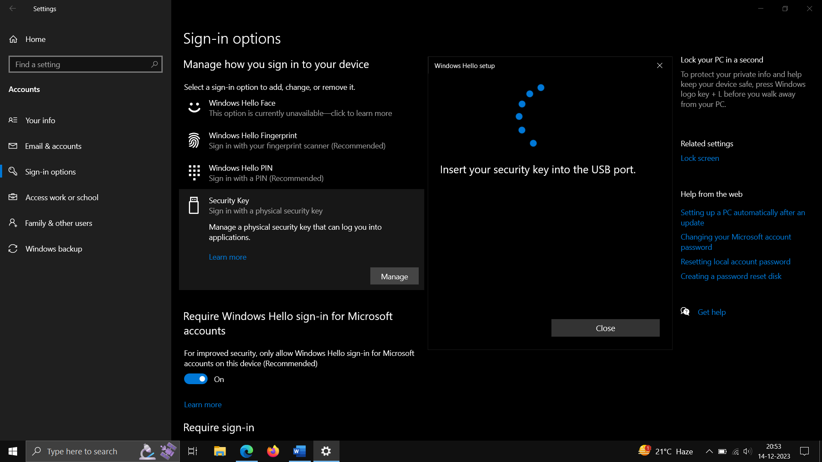

-Disallow users from creating and logging in with Microsoft accounts.

Use windows Registry for setting Key for -HKEY_LOCAL_MACHINE\SOFTWARE\MICROSOFT\Windows|CurrentVerison\Policies\System­­­

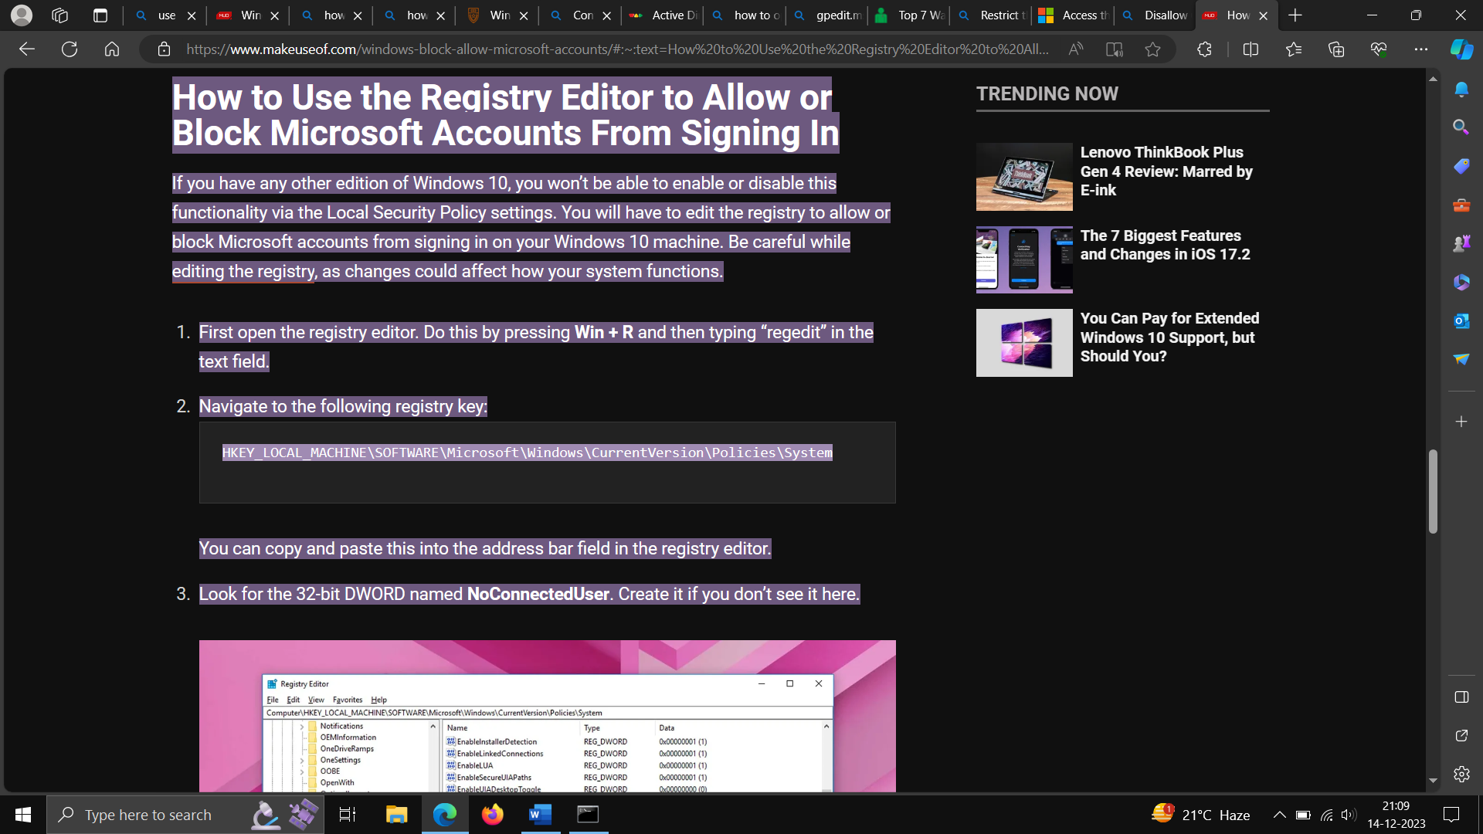

-Require Ctrl+Alt+Del for interactive logins

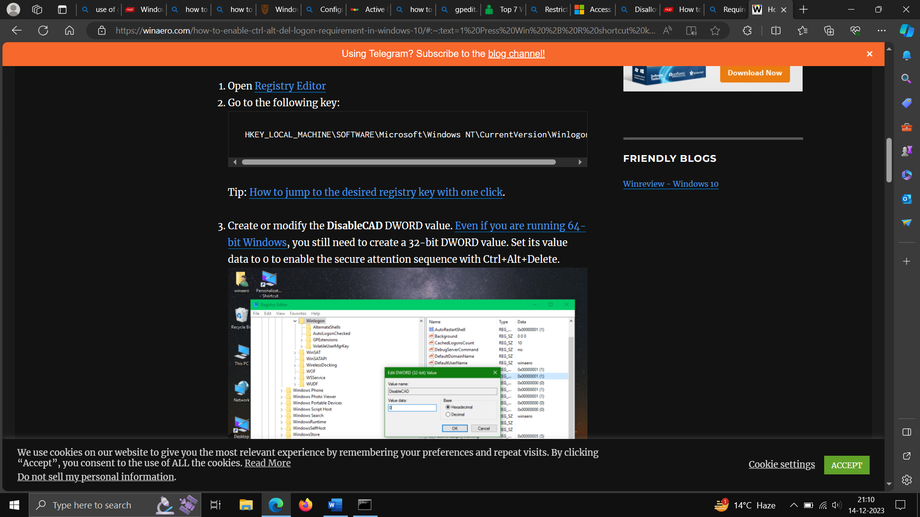

-Unless the server is in the UDC or a managed VM cluster, set a BIOS/firmware password to prevent alterations in system start up settings.

Reference -[Deploy a cluster set for Windows Server Failover Clusters | Microsoft Learn](https://learn.microsoft.com/en-us/windows-server/failover-clustering/cluster-set)

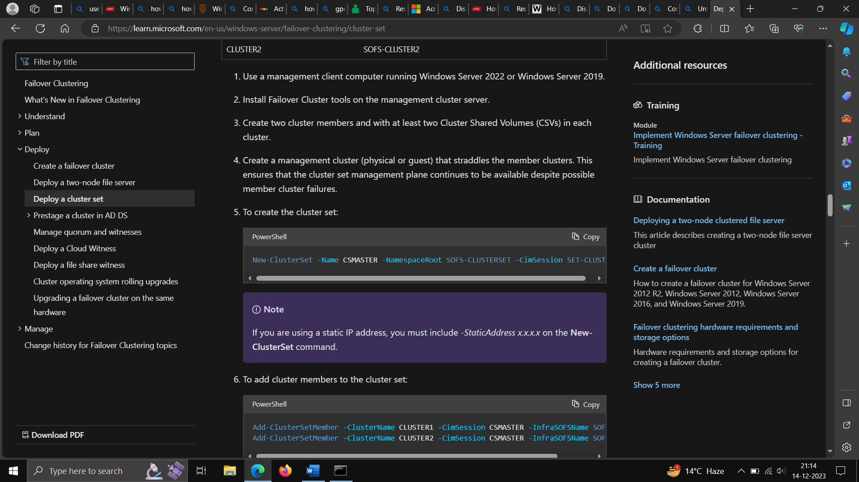

-Screen Saver timeout

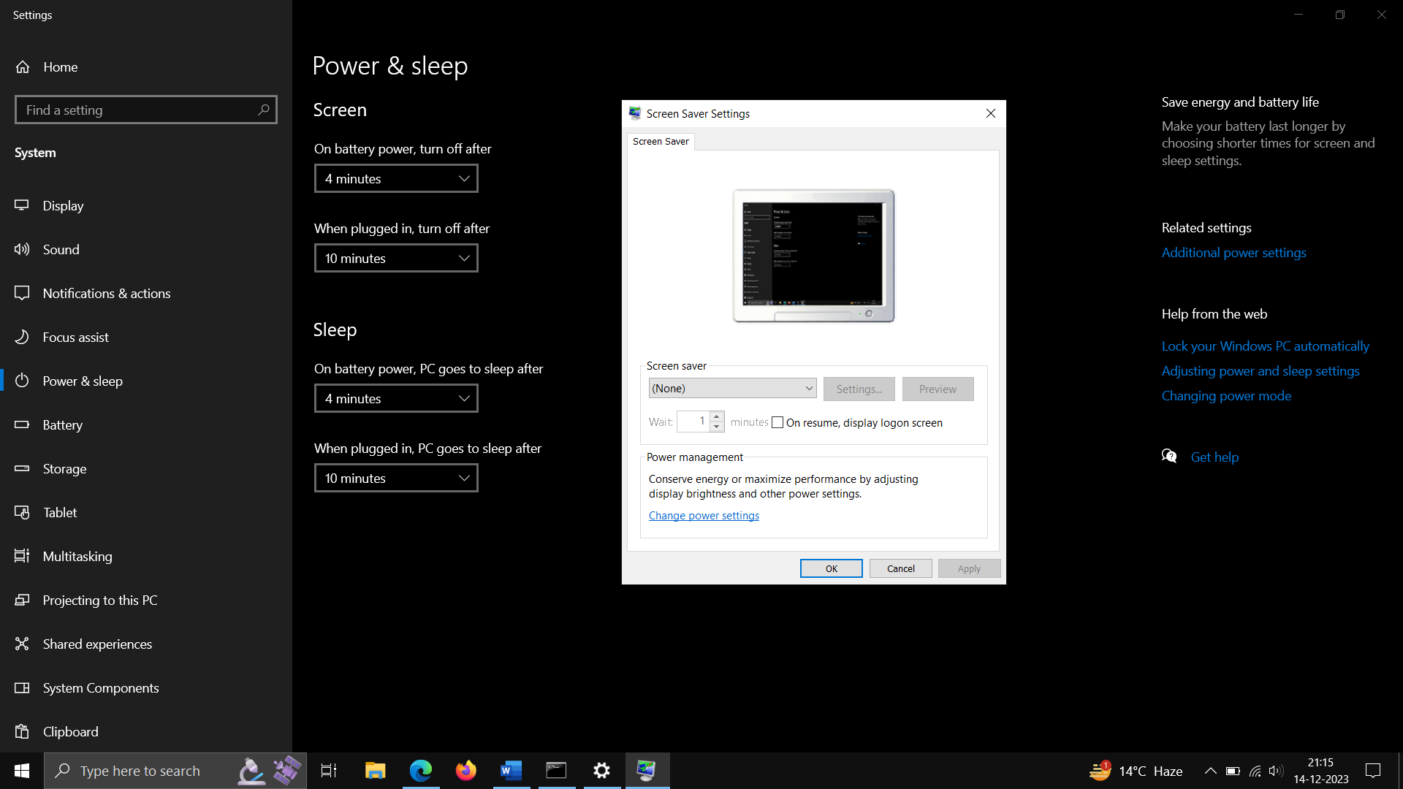

-Configure the device boot order to prevent unauthorized booting from alternate media.

Open start – then system configuration and then boot options.

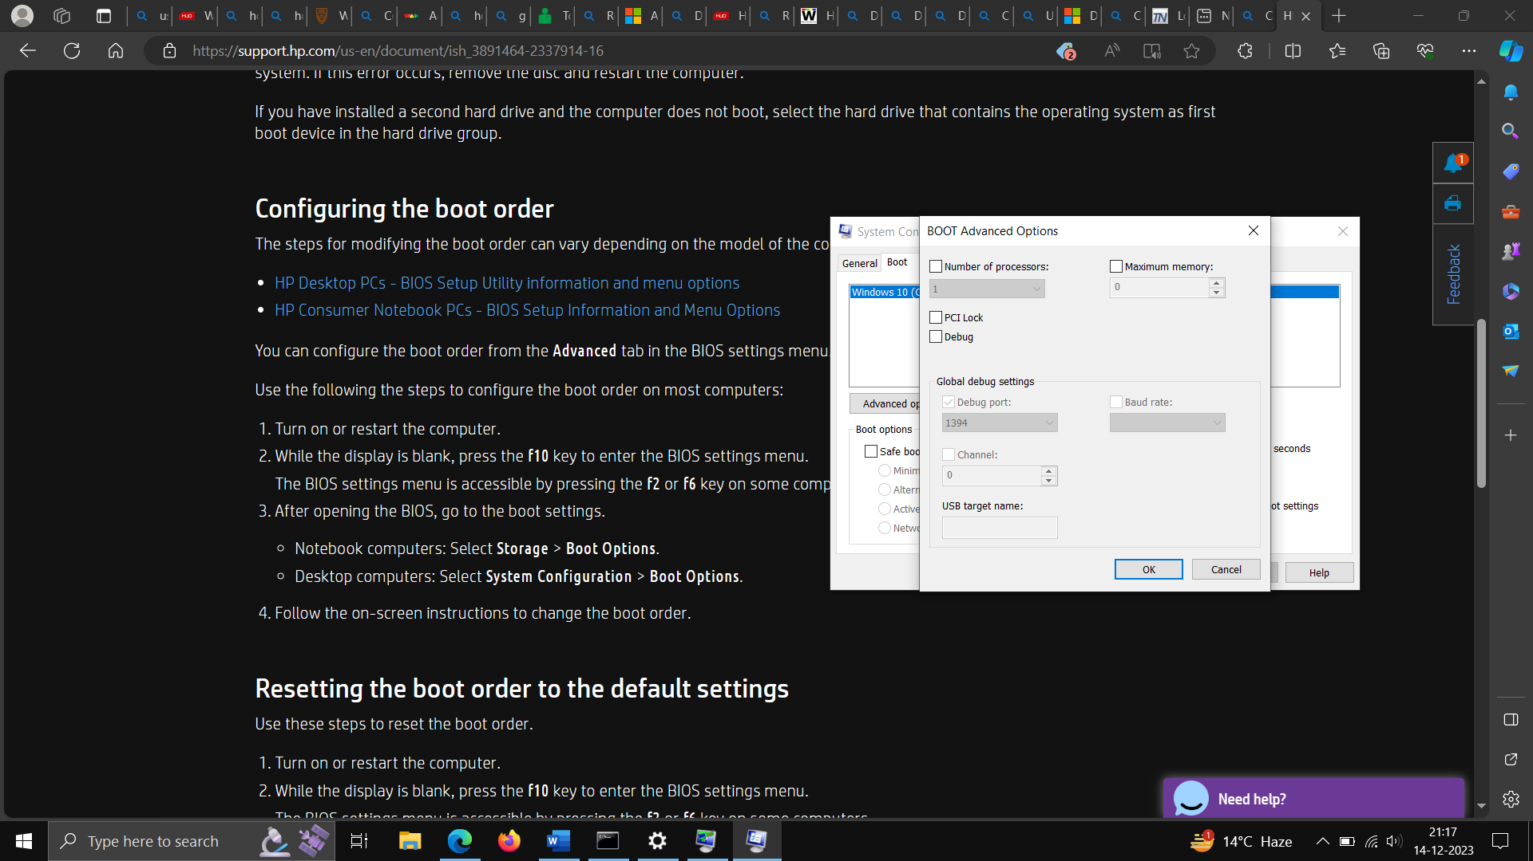

-Configure account lockout policy in windows

Use window+run -type gpedit.msc for user access console management

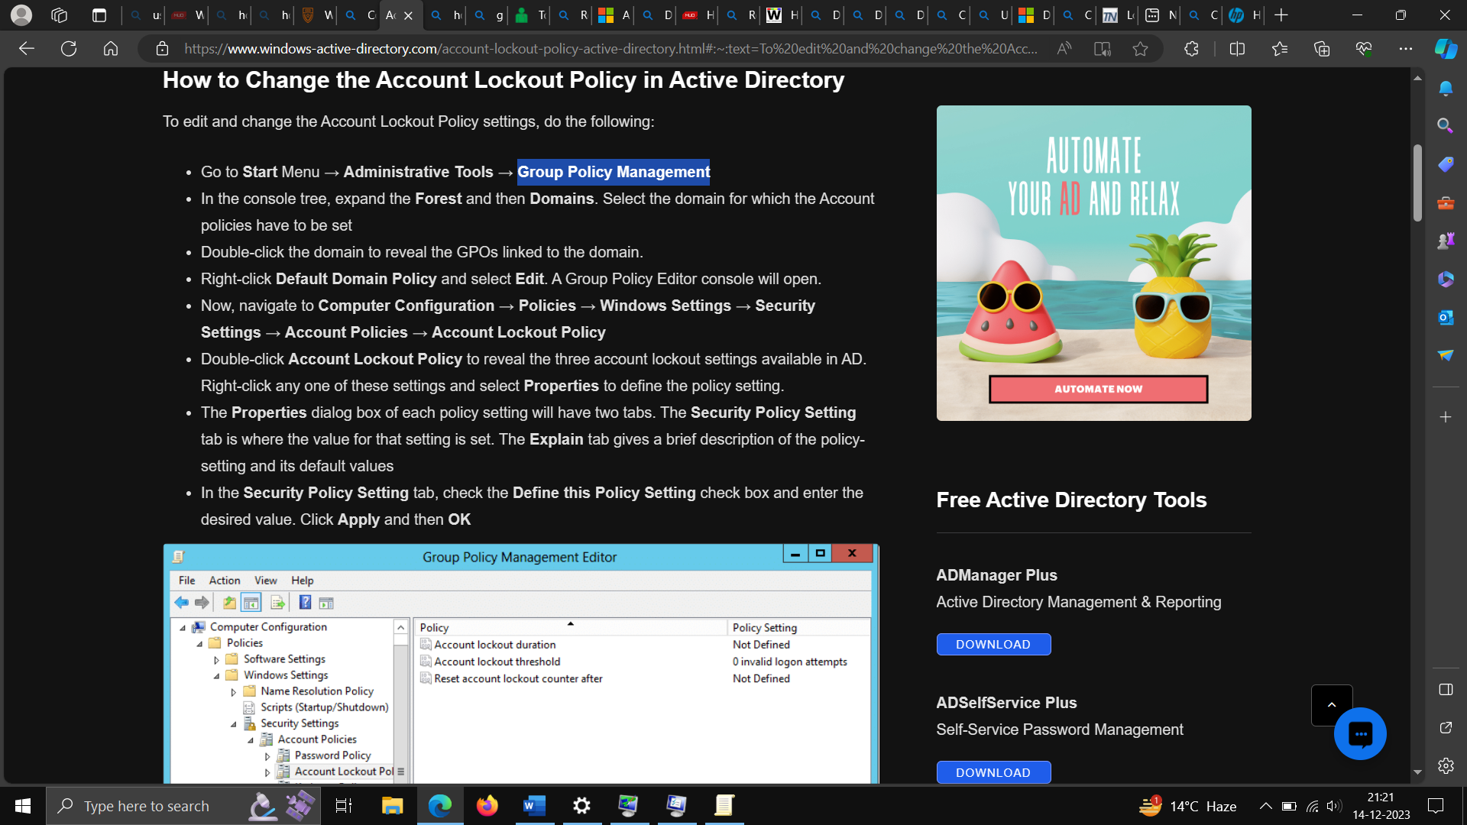

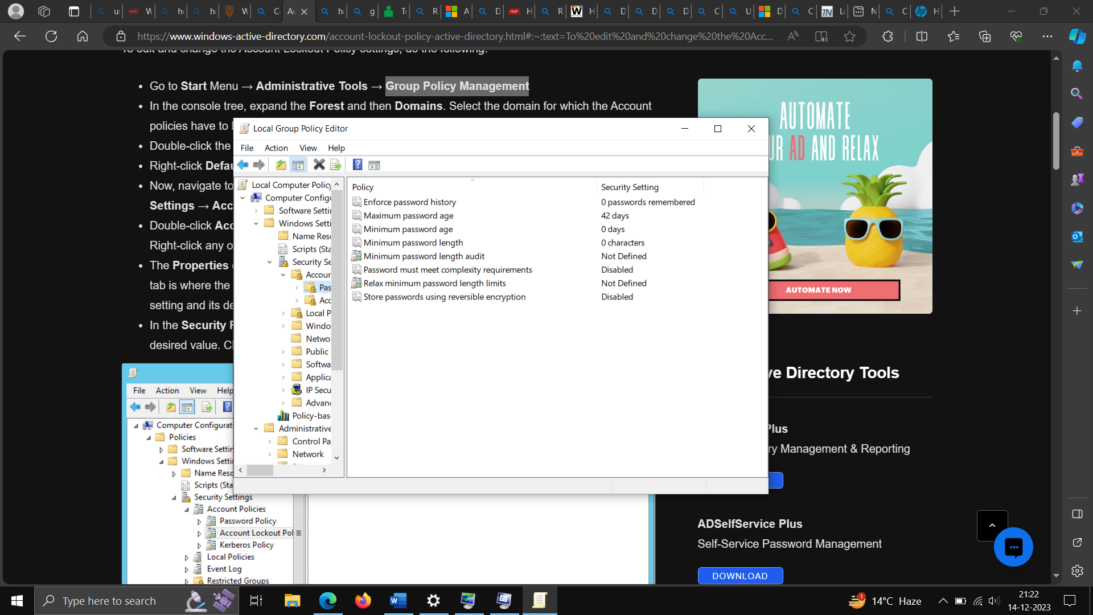

-Configure file system permissions. in windows- usage -click start then privacy settings

